YADAVINDRA DEPARTMENT OF SCIENCES
PUNJABI UNIVERSITY GURU KASHI CAMPUS DAMDAMA SAHIB (TALWANDI SABO)
ADMISSION FORM M. Sc (Mathematics)
Session 2023-24

Diary No. / Date…………………………………………………………………………………….
Initials of the office In-charge………………………………………………………………...
Signatures of the admission committee
1………………………………….2…………………………………….3………………………………..

- FULL NAME (in Block Letters)

- FATHER’S / GUARDIAN’S NAME

- MOTHER’S NAME

- GENDER 5. DATE OF BIRTH 6. NATIONALITY

- CATEGORY

- STATE OF DOMICILE

- DIVISION UNDER WHICH ADMISSION SOUGHT (√ the option)

  - 85% (PUNJAB RESIDENTS)

  - 15% (OTHER STATE)

- EDUCATIONAL QUALIFICATION

NAME OF EXAMINATION

MATRICULATION 10+2 / ANY OTHER

UNIVERSITY / YEAR OF BOARD PASSING
MARKS OBTAINED/ CGPA

TOTAL MARKS
% AGE

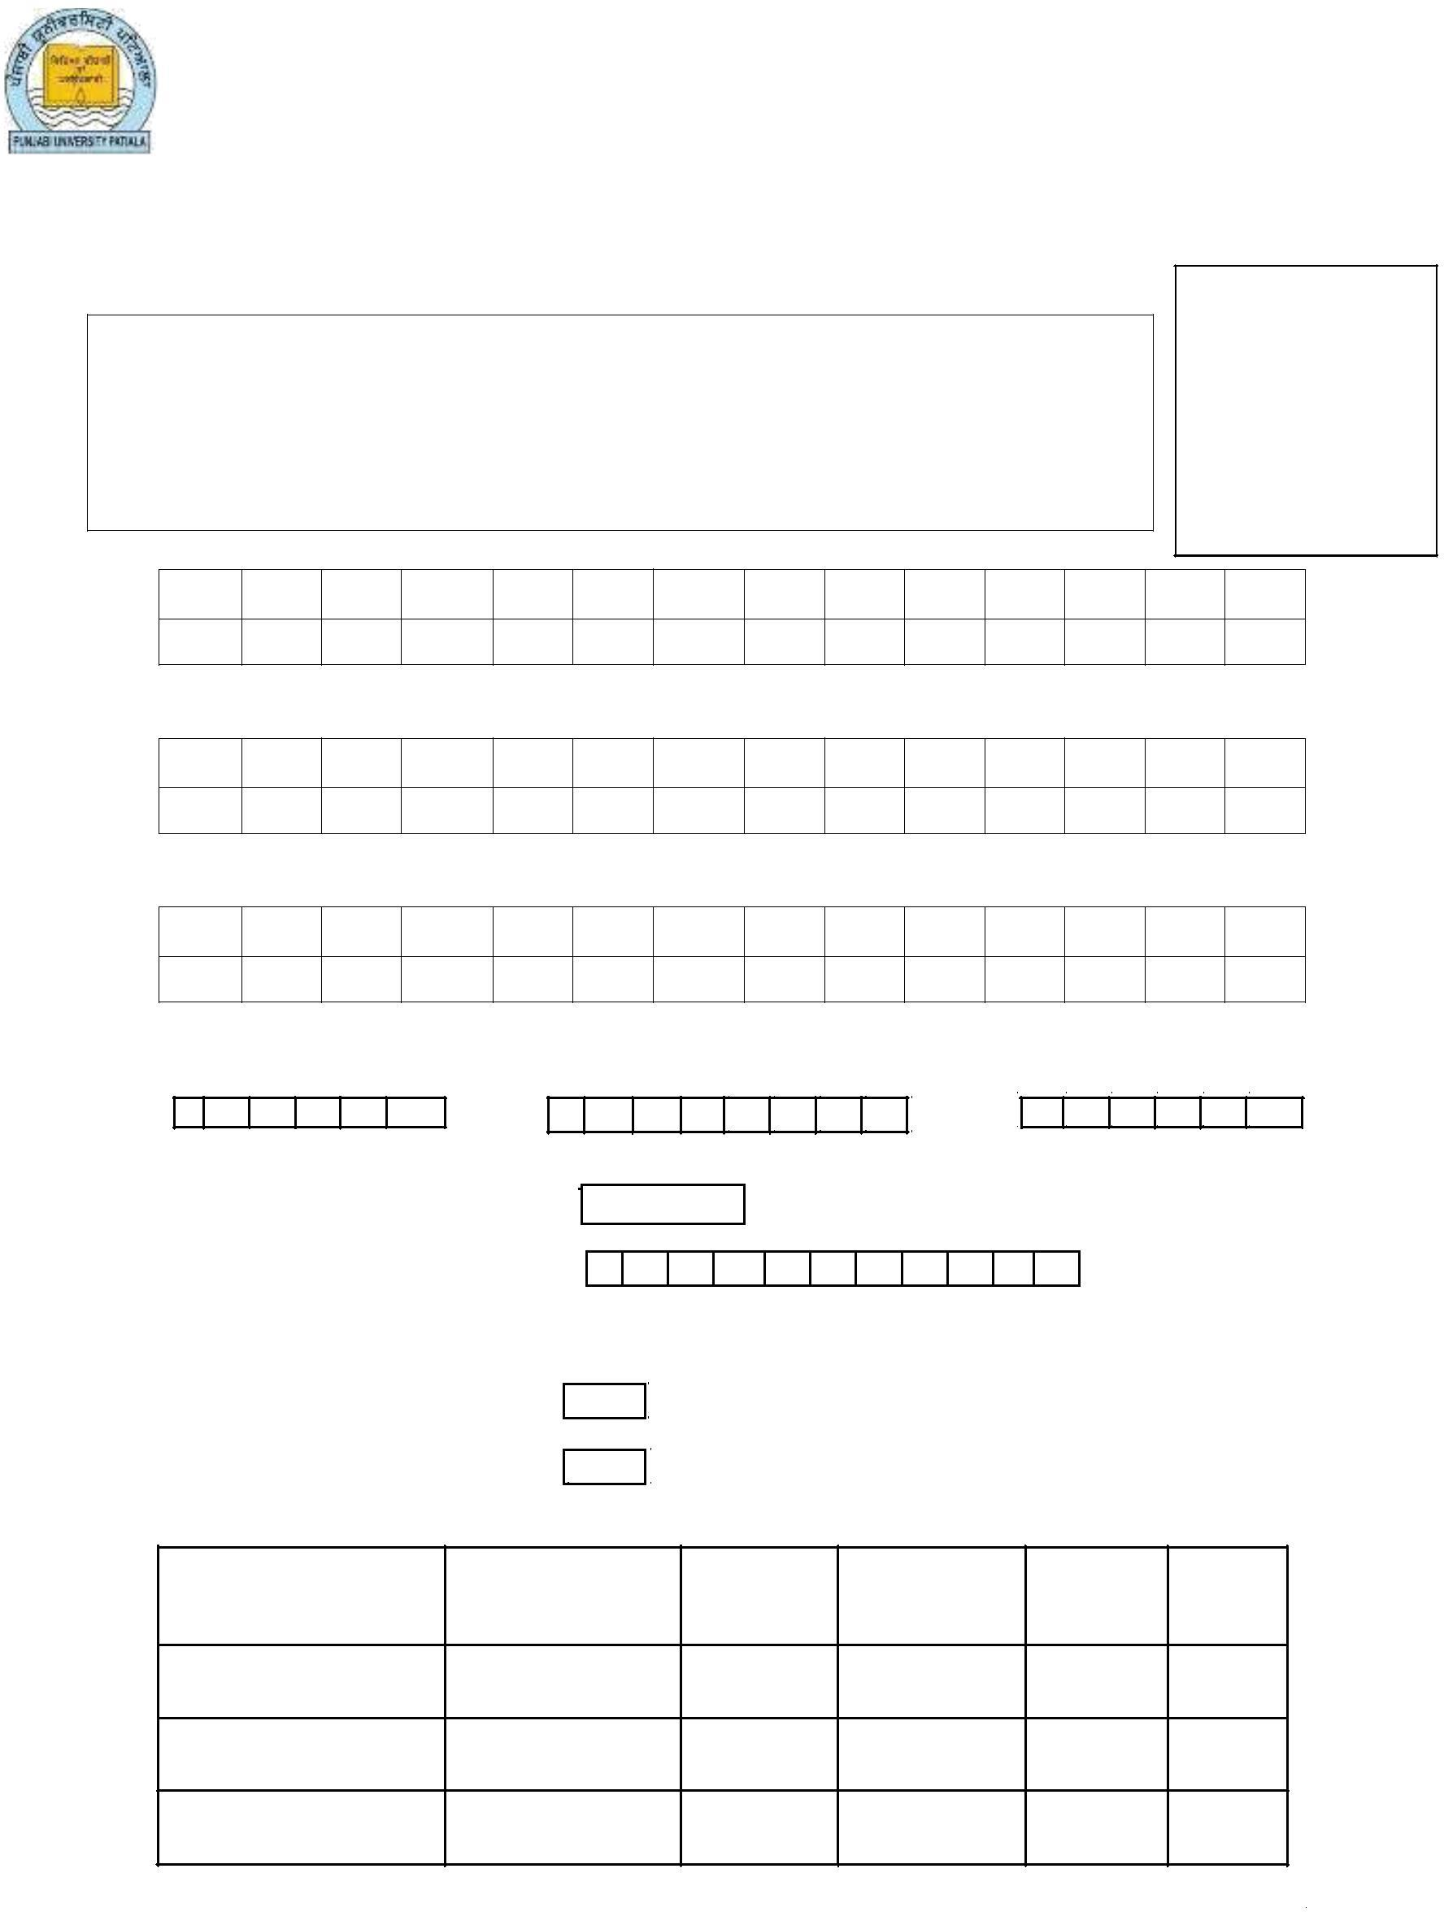
Note : Attach attested copies of marks sheets of each class

- Have You cleared Punjab Matriculation Exam?
Yes | No

12. Permanent Home Address ……………………………………………………………………………………………….

……………………………………………………………………………………………….

………………………………………………………………………………………………..
- Gap in Studies (if Yes attach gap certificate. Yes Or No

14. Telephone No. with STD Code………………………………………….Mobile No 1.…………………………………….

14. Email id :………………………………………………………………………Mobile No. 2…………………………………......
CERTIFICATE BY THE CANDIDATE
I declare that the entries made by me in this form are correct to the best of my knowledge.
I undertake to abide by the rules of PUNJABI UNIVERSITY PATIALA.

Place…………………………
………………………………….…
Date………………………….. Signature of the candidate

LIST OF CERTIFICATES TO BE ATTACHED WITH THE APPLICATION DULY ATTESTED
  - Matriculation certificate.
  - Detail marks certificate of 10+2.
  - Detail marks certificate of Bachelor Class.
  - Character Certificate from the institution last attended.
  - Certificates for availing the benefit of a reserved seat.
  - Residence certificate (If admission is given against 85% quota).
  - Affidavit of the Parent/Guardian to be attested by an executive magistrate/Oath Commissioner/Notary Public in case of category a & b of serial no. 9 (Appendix-A).
  - Migration Certificate
  - Any other document supporting your candidature.
Admission Form complete in all respects must be submitted to the Head, Yadavindra Department of Sciences (YDoS), Talwandi Sabo (Bathinda) along with a bank draft of Rs. 800/- (Rs. 400/- For SC/ST) as Application/Processing fee, Drawn in favour of Head, Yadavindra Department of Sciences Payable at Talwandi Sabo in stipulated time frame. Application fee can also be deposited in any branch of SBI in the account of Head, Yadavindra Department of Sciences (Account No. 40978653880 IFSC- SBIN0050058)

All disputes arising from this document or connected therewith are subject to the territorial jurisdiction of courts situated at Patiala only and to the exclusion of all other courts.

APPENDIX-A

Self-Declaration
(Not Claiming Residence in any other state)

I ................................................................................................
PHOTO
father/mother/guardian of Miss/Mr. ..........................................
Resident of ................................................................................

..................................................................................................

...................................................................................................
(full address to be given)
do hereby solemnly state and affirm as under: -

- That I am a citizen of Indian.
- That neither the deponent not the child/ward of deponent have obtained the benefit of Residence in any other state.

DEPONENT
Dated.........................

Verified that the contents of my above affidavit are true and correct to the best of my knowledge and belief and nothing has been concealed there from.

Dated. ....................... DEPONENET

